Low Level Design (LLD) – SOPAN Jal Rekha Project

1. Introduction
This Low-Level Design (LLD) document provides detailed technical specifications for the SOPAN Jal Rekha project. It includes database design (ER diagram), sequence diagrams for core workflows, class diagrams, API contracts in JSON/XML, and component-level design to guide development and testing teams.

2. System Architecture Overview
- Frontend: .net for web portal and reports.
- Backend: RESTful APIs using WCF.
- Database: PostgreSQL.
- Authentication: RBAC for authorization.
- Hosting: Cloud with load balancer, backups, and DR.

3. Module-wise Design (Summary)
Modules covered: Planning, Monitoring, Verification, Approval, Reporting.

4. Entity-Relationship (ER) Diagram
Core entities illustrated: user master, scheme master, users, sopan_work_monitoring, sopan_work_monitoring_pre_cast,mst_sopan_status,mst_sopan_stages_construction.
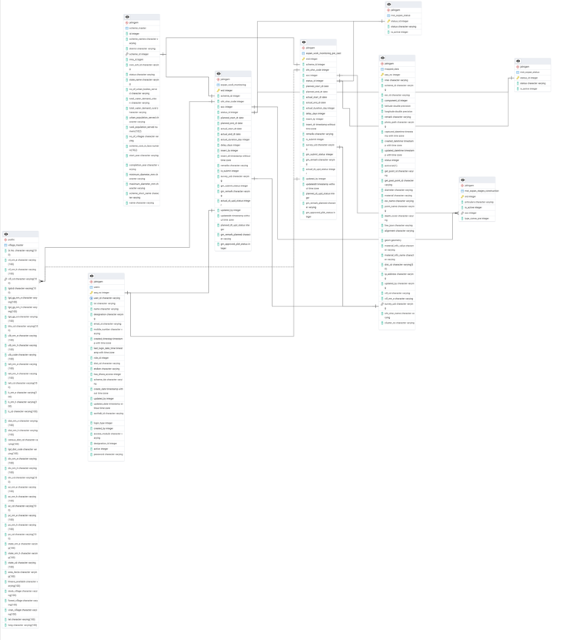
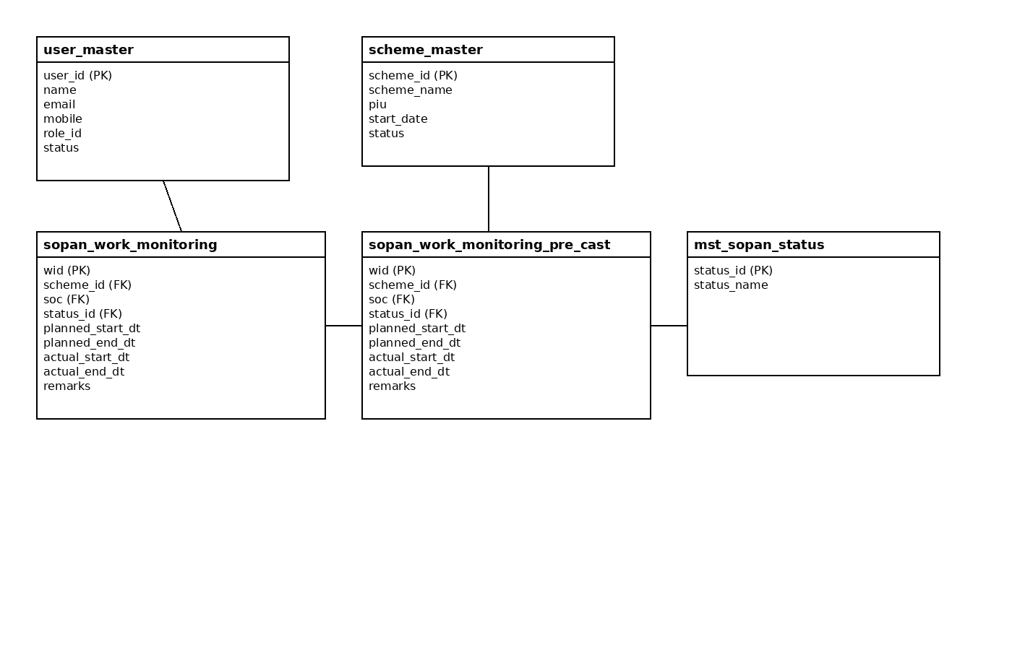

Figure: Simplified ER diagram showing core tables and relationships.

5. Sequence Diagram - Planning Workflow
Contractor Planned Date Submission → GM Verification & Freeze → GM Actual Date Entry → Review & Approve / Reject. 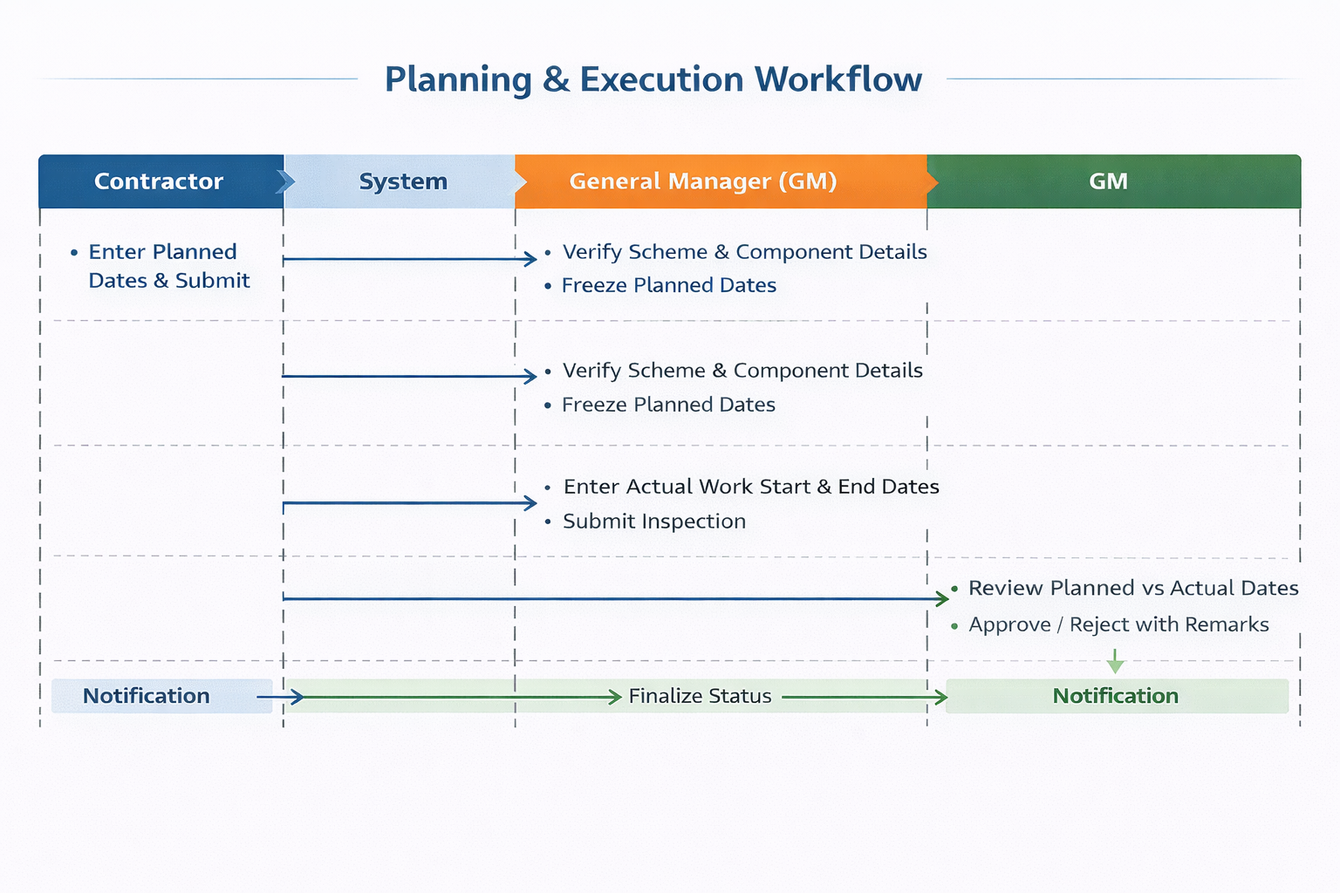

7. Class Diagram (Simplified)
Classes: User, Scheme, sopan_work_monitoring, mst_sopan_stages_construction,.
Attributes and primary methods shown.


8. API Contracts (JSON / XML examples)
POST /api/ sopan /Submit_Sopan_Work_Monitoring_Remark (Request JSON):
{
"scheme_id": "25",
"oht_id": "459643",
"remark": "sad",
"insertby": "40",
"typeofoht": "1",
"survey_uid": "OHT-025-28",
"role_id": "9",
"etoken": "v6h/MN0C2j2M1s8w8run8Vs9U02x7g79KZ 22H5e1YCn55rekAJfXnp8GD335c6Pb6B34D76zEoT0XQ0Qp5fl9 Q688AcKoQb8/p"
}
Response (JSON):
{
"Data": [
{
"json_data": null
}
],
"Message": "Insert_Remark Data Retrieved Successfully",
"Success": true,
"DataLength": 1,
"StatusCode": 200,
"draw": 0,
"recordsTotal": 0,
"recordsFiltered": 0
}
POST /api/sopan/GetSchemeForWork_Monitoring (Request JSON):
{
"scheme_id": "25",
"piu_dist_cd": "0",
"for_search": "regular",
"typeofoht": 0,
"etoken": "v6h/MN0C2j2M1s8w8run8Vs9U02x7g79KZ 22H5e1YCn55rekAJfXnp8GD335c6Pb6B34D76zEoT0XQ0Qp5fl9 Q688AcKoQb8/p"
}
Response (JSON):
{
"Data": [
{
"scheme_id": "25",
"scheme_name": "Bina Khurai "
}
],
"Message": "GetSchemeForWork_Monitoring Data Retrieved Successfully",
"Success": true,
"DataLength": 1,
"StatusCode": 200,
"draw": 0,
"recordsTotal": 0,
"recordsFiltered": 0
}

9. Appendix - Table Schemas (DDL style)
Sample DDL snippets for core tables (PostgreSQL):
CREATE TABLE user_master (
user_id SERIAL PRIMARY KEY,
name VARCHAR(200) NOT NULL,
email VARCHAR(200) UNIQUE NOT NULL,
mobile VARCHAR(20) UNIQUE,
role_id INT,
status VARCHAR(20),
created_at TIMESTAMP DEFAULT now()
);
CREATE TABLE scheme_master (
scheme_id SERIAL PRIMARY KEY,
scheme_name VARCHAR(255) NOT NULL,
piu VARCHAR(200),
start_date DATE,
status VARCHAR(20)
);
CREATE TABLE IF NOT EXISTS jalnigam.users
(
seq_no integer NOT NULL DEFAULT nextval('jalnigam.users_seq_no_seq'::regclass),
user_id character varying COLLATE pg_catalog."default",
txt character varying COLLATE pg_catalog."default",
name character varying COLLATE pg_catalog."default",
designation character varying COLLATE pg_catalog."default",
email_id character varying COLLATE pg_catalog."default",
mobile_number character varying COLLATE pg_catalog."default",
created_timestap timestamp with time zone DEFAULT now(),
last_login_date_time timestamp with time zone DEFAULT now(),
role_id integer,
dist_cd character varying COLLATE pg_catalog."default",
etoken character varying COLLATE pg_catalog."default",
has_dhara_access integer DEFAULT 0,
scheme_ids character varying COLLATE pg_catalog."default",
create_date timestamp without time zone DEFAULT now(),
updated_by integer,
updated_date timestamp without time zone DEFAULT now(),
sarthak_id character varying COLLATE pg_catalog."default",
login_type integer,
created_by integer,
access_module character varying COLLATE pg_catalog."default",
designation_id integer,
active integer,
password character varying COLLATE pg_catalog."default",
CONSTRAINT users_pkey PRIMARY KEY (seq_no),
CONSTRAINT users_user_id_key UNIQUE (user_id)
)
CREATE TABLE IF NOT EXISTS jalnigam.sopan_work_monitoring
(
wid integer NOT NULL DEFAULT nextval('jalnigam.sopan_work_monitoring_wid_seq'::regclass),
scheme_id integer,
oht_ohsr_code integer,
soc integer,
status_id integer,
planned_start_dt date,
planned_end_dt date,
actual_start_dt date,
actual_end_dt date,
actual_duration_day integer,
delay_days integer,
insert_by integer NOT NULL,
insert_dt timestamp without time zone DEFAULT now(),
remarks character varying COLLATE pg_catalog."default",
is_submit integer DEFAULT 0,
survey_uid character varying COLLATE pg_catalog."default",
gm_submit_status integer DEFAULT 0,
gm_remark character varying COLLATE pg_catalog."default",
actual_dt_upd_status integer DEFAULT 0,
updated_by integer,
updateddt timestamp without time zone,
planned_dt_upd_status integer DEFAULT 0,
gm_remark_planned character varying COLLATE pg_catalog."default",
gm_approved_pldt_status integer DEFAULT 0,
CONSTRAINT sopan_work_monitoring_pkey PRIMARY KEY (wid),
CONSTRAINT fk_prticulares FOREIGN KEY (soc)
REFERENCES jalnigam.mst_sopan_stages_construction (sid) MATCH SIMPLE
ON UPDATE NO ACTION
ON DELETE NO ACTION,
CONSTRAINT fk_status_id FOREIGN KEY (status_id)
REFERENCES jalnigam.mst_sopan_status (status_id) MATCH SIMPLE
ON UPDATE NO ACTION
ON DELETE NO ACTION
NOT VALID,
CONSTRAINT fk_survey_mappeddata FOREIGN KEY (survey_uid)
REFERENCES jalnigam.mapped_data (survey_uid) MATCH SIMPLE
ON UPDATE NO ACTION
ON DELETE NO ACTION
NOT VALID,
CONSTRAINT check_insert_by CHECK (insert_by > 0)
)

CREATE TABLE IF NOT EXISTS jalnigam.sopan_work_monitoring_pre_cast
(
wid integer NOT NULL DEFAULT nextval('jalnigam.sopan_work_monitoring_conventional_wid_seq'::regclass),
scheme_id integer,
oht_ohsr_code integer,
soc integer,
status_id integer,
planned_start_dt date,
planned_end_dt date,
actual_start_dt date,
actual_end_dt date,
actual_duration_day integer,
delay_days integer,
insert_by integer,
insert_dt timestamp without time zone DEFAULT now(),
remarks character varying COLLATE pg_catalog."default",
is_submit integer DEFAULT 0,
survey_uid character varying COLLATE pg_catalog."default",
gm_submit_status integer DEFAULT 0,
gm_remark character varying COLLATE pg_catalog."default",
actual_dt_upd_status integer DEFAULT 0,
updated_by integer,
updateddt timestamp without time zone,
planned_dt_upd_status integer DEFAULT 0,
gm_remark_planned character varying COLLATE pg_catalog."default",
gm_approved_pldt_status integer DEFAULT 0,
CONSTRAINT sopan_work_monitoring_conventional_pkey PRIMARY KEY (wid),
CONSTRAINT fk_prticulares FOREIGN KEY (soc)
REFERENCES jalnigam.mst_sopan_stages_construction (sid) MATCH SIMPLE
ON UPDATE NO ACTION
ON DELETE NO ACTION,
CONSTRAINT fk_status_id_conventional FOREIGN KEY (status_id)
REFERENCES jalnigam.mst_sopan_status (status_id) MATCH SIMPLE
ON UPDATE NO ACTION
ON DELETE NO ACTION,
CONSTRAINT fk_survey_mappeddata_conventional FOREIGN KEY (survey_uid)
REFERENCES jalnigam.mapped_data (survey_uid) MATCH SIMPLE
ON UPDATE NO ACTION
ON DELETE NO ACTION,
CONSTRAINT check_insert_by CHECK (insert_by > 0)
)

10. Module-wise Low-Level Design

10.1 Sopan (Work Monitoring & Planning)
Database Tables
work_plan(plan_id, scheme_id, component_id, contractor_id, planned_start, planned_end, approved_by, status)
work_progress(progress_id, plan_id, actual_start, actual_end, progress_percent, photo_url, remarks)
APIs
POST /work/plan → Create plan
POST /work/progress → Update progress
POST /work/Approve → Approve Planes
GET /work/report?scheme_id → Work monitoring reports
GET /work/report?scheme_id,OHT/WTP/IPS/Intake well Id → Work monitoring reports
GET /work/report?Constaruction Type Id → Work monitoring reports

Workflow
- Contractor creates work plan.
- GM Freez/approves/rejects plan.
- Contractor and GM uploads Documents.
- Reports generated.

10.8 Reporting
Data Sources
Mapped OHT Details, Sopan Report, Work Monitoring Details
APIs
GET /report/ GetMapped_OHT?scheme_id → Fetch report
GET /report/ GetINTAKEForWork_Monitoring? scheme_id → Fetch report
Workflow
- Reports displays scheme-wise, Type of OHT/WTP/Intake/IPS, OHT/WTP/Intake/IPS wise.
- Export available in XLSX/PDF.

11. Error Handling
- API request validation (mandatory fields, value ranges).
- Graceful fallback for offline → sync scenarios.
- Audit logging for all CRUD and approval actions.

12. Security
- Role-based access control (RBAC).
- Token-based authentication.
- Data encryption at rest (PostgreSQL TDE) and in transit (HTTPS/TLS).

13. Sequence Diagrams (to be included)
Contractor Planned Date Submission → GM Verification & Freeze → GM Actual Date Entry → Review & Approve / Reject.

